Town Board Proclamation

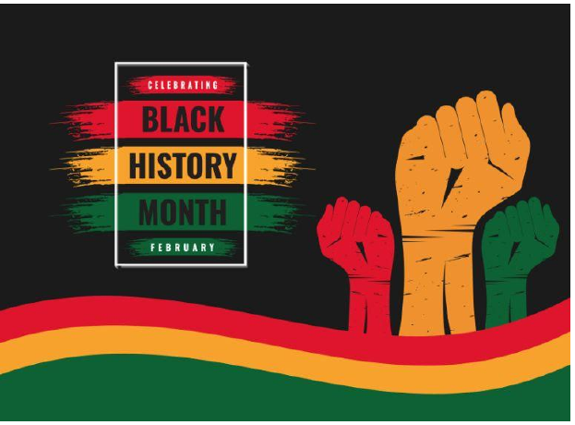

Throughout the month of February each year, we recognize and celebrate the contributions of African Americans to this country, and we acknowledge and appreciate their achievements. From February 1 through March 1, 2025, in honor of Black History Month.

African Americans have played a central role in U.S. history. Carter G. Woodson, who in 1915 founded ASNLH (Association for the Study of Negro Life and History), now ASALH (Association for the Study of African American Life and History), sought to preserve such history and to promote Black American achievement. Not until 1976 was Black History Month officially recognized by then President Gerald Ford.

Our collective town history must encompass all citizens, past and present. Remember Harriet Tubman, Martin Luther King, Jr., certainly, but also recognize those who were / are less fortunate, are / were less renown, but nonetheless belonged / belong to this, our collective community. Resist anything that lessens African Americans. We are better than that - we must do better. Let our legacy be one that aligns ourselves with our neighbors – all of our neighbors, and be good stewards of the history of all who inhabit our county.

Given under my hand at the New Lebanon Town Hall, New Lebanon, New York this 11th day of February in the year 2025.

_________________________________________________________
Tistrya Houghtling, Supervisor
New Lebanon Town Board

